Military Family Support Online Discussion Group-What We’re Doing

We’re an open group of parent center directors and staff who share and support one another in their work serving military-connected families. Drop in during our monthly meeting hour or come early and stay-ask a question, share an insight—it’s what we’re all about, and you are cordially welcome!

January 2020
Resources:
Based on the discussion
- “Military Families, Welcome to Our State”
- Early Intervention Directory from Military Onesource
- Education Directory for Children with Special Needs
- DoD Directory of Early Intervention, Special Education and Related Services in OCONUS Communities (outside continental US)
The Branch has published 2 resources that list useful agencies and programs that operate in every state
- 16 Financial Resources for Military Families (includes agencies that offer services and supports)
- Post-High School Transition Resources for Military Families
And links for Medicaid agency information:
- You can find information on each state or territory’s Medicaid program, and learn where and how to apply for your child’s benefits at this site
- You can find out about state waiver programs at this site

Link to PHP’s Twitter page: https://twitter.com/phpeducation. Click on the dropdown to see the public list for “Military Family Disability. (Read more about this resource in Discussion, below.)
Announcement: Branch-MPTAC is convening a youth advisory group of military youth and young adults to be a resource for the Parent Center Network and national military family-serving organizations. Our “soft launch” will be Feb. 12, and we’ll be asking all of you to help us get the word out to military families and your installation contacts. If you have any thoughts about this group, please feel free to contact Barb Koumjian: bkoumjian@wapave.org.
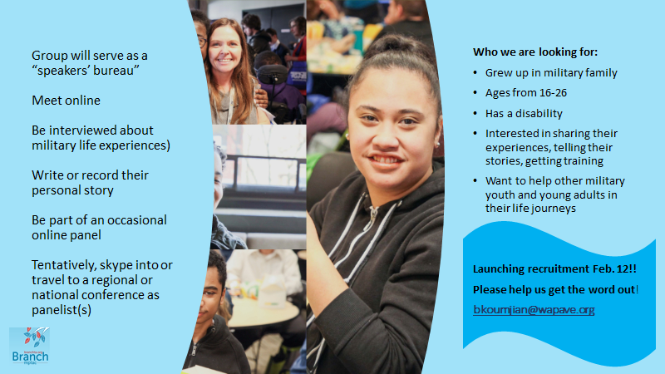

We had a record number of participants this month! We welcomed Mike Tufte, PTI Nebraska, NB; Rocio Lopez, TASK, CA; Jennifer Zucati, LINKS Mat-Su, AK; and two members of the Exceptional Family Member Program (EFMP) staff from Hill Air Force Base in Utah, Tammy Custer and Alysse Seligman. (sadly, technical issues prevented their full participation). Thanks for to all of you for joining us and we hope to “see” you again!
Correction: Apologies to Vickie Crocker, Vermont Family Network, for misspelling her name in the previous notes.
A full list of participants is included at the end of this month’s notes. You can grab folk’s emails from the “To” address bar in the email to which these notes are attached.
Discussion: Key things to know about military families (for parent center staff unfamiliar with active-duty military life)
- They move a lot
- Services must be started over in each new state
- Military families are frequently unfamiliar with parent centers
- It’s difficult to find out needed information for new states
- Differences in the names of agencies, definitions, eligibility, and what agencies and programs do what.
- Timelines: when are application deadlines for eligibility for services in state and community-level agencies and programs?
Addressing issue #3, how do we help military families know parent centers exist?
- Several folks mentioned regularly scheduled check-ins with EFMP staff and School Liaisons, as well as time-sensitive communication for events, trainings, etc.
  - When checking in with installation contacts, finding out about new staff and introducing yourself
- Getting invited to installation resource fairs, maintaining relationships to keep the invitations coming
- Sharing listservs, newsletters, email blasts with contacts on installations
- Celebrating key promotions like “Month of the Military Child” on social media
- Parents Helping Parent (Loni Allen) specifically calls out the “Find Your Parent Center” feature at parentcenterhub.org on Twitter, with hashtags #PTI, #military.
  - They also dedicate a regularly scheduled tweet to military family concerns and resources.
Loni followed up with an email:
I created a 'list' on PHP's twitter account titled Military Fam Disability
I have started adding twitter accounts that post good content or families or guardians who have a child or young adult with any disability.
Other people can 'follow' or have access to my list, as I"ve made it public
;-)
Here's an example of a twitter account posting content:
Athersys Inc
@athersys
May 21, 2018
Join us this #MilitaryMonday in increasing #traumaawareness. #DYK #TBI is a leading cause of serious #disability, especially among #youngpeople that suffer #trauma and members of the #military. Learn more the
@CDCgov
: https://cdc.gov/traumaticbraininjury/get_the_facts.html

- Link to PHP’s Twitter page: https://twitter.com/phpeducation

Resources-details and ideas to use:
“Military Families, Welcome to Our State”
This resource was created by our group working together with the Branch!
Some issues might be addressed when parent center place their version of “Military Families, Welcome to Our State” in their resources, promote it on social media, and (most important) give it to installation EFMP staff and School Liaisons. Families checking with a “gaining” installation could find lots of this information in one place.
A suggestion was made that parent centers could submit their state’s information to a central spot online for any parent center staff and military families to find.
  - If a central spot was created, how could we best get out the word to military families?
  - Where could it “live”? Who would maintain it?
Department of Defense has 3 directories, one on Special Education per state, and the other on Early Intervention services per state. Unfortunately, they seem incomplete, and they don’t cover other agencies and programs that military families need (like Medicaid, Developmental Disabilities Agencies, Voc. Rehab, etc.).
- Early Intervention Directory from Military Onesource
- Education Directory for Children with Special Needs
- DoD Directory of Early Intervention, Special Education and Related Services in OCONUS Communities (outside continental US)
The Branch has published 2 resources that list useful agencies and programs that operate in every state:
- 16 Financial Resources for Military Families (includes agencies that offer services and supports)
- Post-High School Transition Resources for Military Families
And links for Medicaid agency information:
- You can find information on each state or territory’s Medicaid program, and learn where and how to apply for your child’s benefits at this site
- You can find out about state waiver programs at this site

Attending:
- Kathy Powell, FND-POPIN, FL
- Ginger Manley, FND-POPIN, FL
- Mike Tufte, PTI Nebraska, NB
- Wanda Merchan, HUNE, PA
- Loni Allen, PHP, CA
- Terri Leyton, ECAC & Region B PTAC, NC
- Corey Yarrow, Families Together, Inc., KS
- Shirley Swope, PEAK, CO
- Alejandra Rivera, EPU, CA
- Jennifer Zucati, LINKS Mat-Su, AK
- Rosslin Mensah-Boateng, SPAN, NJ
- LaJoy Johnson-Law, AJE-DC, DC
- Anya Frederickson, PEAL, PA
- Elizabeth Allen, Family Connection of SC, SC
- Rocio Lopez, TASK, CA
- Tammy Custer, Hill AFB EFMP, UT
- Alysse Seligman, Hill AFB EFMP, UT

There was no discussion in December 2019

November 2019
Requested resource: the guide to Branch website resources that includes both core and “advanced” topics about military families: Easy Branch Orientation and Guide to Staff Training. It’s also attached to the email.
We welcomed Leia Holley, Families Together, Kansas, and Vickie Crocker, Vermont Family Network, Vermont.
News: The discussions are now open to any Parent Center that wants to participate, whether or not the Center is in the “Top 12” most highly military-impacted states.
We anticipate that November’s Bugle, coming out next week, will include all the details on the special resource created last year by this group, “Welcome to Our State for Military Families”. The resource package includes a template for both a web page and a handout, and your center can completely customize both with information on education, supports, services, for your state. There is a copy of the handout example created by ECAC in North Carolina attached to your email
We will also have some quick information about the recent OSEP guidance on compensatory education when relocating to another state. Stay tuned!
Topic: The bulk of the discussion focused on learning about the feedback sent by many of you in response to the Branch email titled: What do you want? It’s about what the group would like to do this coming year, and the responses are attached to your email. We’re sending out a follow-up email for people who haven’t yet had the chance to respond.
Other topics:
- What is the most useful/most streamlined way to help a military family relocation into your state, when the family previously had a residential educational placement?
- How can we most usefully assist a military family to get Medicaid supports and services when relocating to your state?
- Complex needs: Yasmeen Butler, STOMP, pointed out that the “typical military relocation schedule” of approximately every 3 years may not necessarily apply to individual families. Each branch of service has a process, sometimes called “Compassionate Reassignment”, where a family in the Exceptional Family Member Program can work with their local EFMP Family Support to apply for this type of “stay in place” assignment. It’s not in any way guaranteed, however.
- Families Together, Kansas, has previously worked with MilitaryOneSource, the online program and website that offers a wide range of non-medical counseling options for military families. Those counselors have reached out to Families Together to get TA on helping families who call in to them. Families Together staff have usually suggested that the Military OneSource counselors refer families directly to the Parent Centers, as TA may not “translate” as secondhand information. This raises some interesting possibilities for all of our work, with potential new collaboration with these counselors.

October 2019
A New Name: What name would help this standing discussion feel warm and welcoming to parent centers??
New Question: Is there a military program (or any program) that offers military parents the ability to get parent-center type information and training in multiple languages? And if not, can parent centers reach out to military programs to offer these resources?
We welcomed Wanda Merchan, Bilingual Parent Advisor, HUNE, Philadelphia, PA, and Tony Darren, Technical Assistance Project Specialist, Region D Parent Technical Assistance Center, PEAK Parent Center, CO.
“Burning Question” Answered! At the September meeting this idea was raised:
“We can’t do the work alone. How are parent centers partnering with their state education agency, local districts, schools or others to better serve military families?”
We decided to find out first where and with whom we partner. Many detailed responses came in; thanks so much to everyone who participated to share this information.; below is the summary shared at October’s meeting:
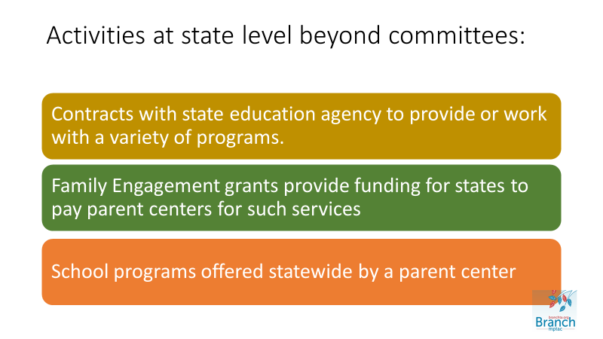
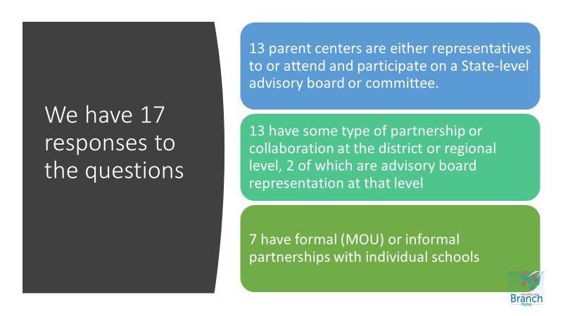
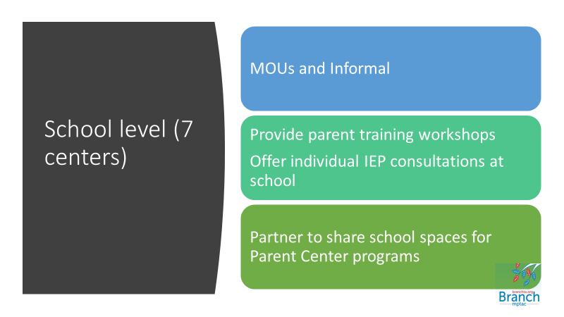
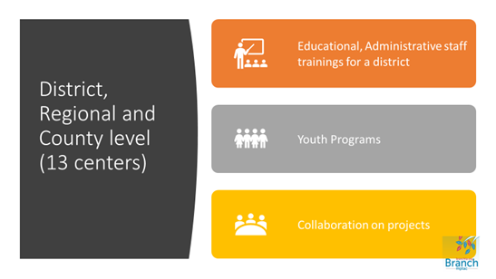

There were suggestions on how partnerships might work to benefit our outreach and service delivery to military families:
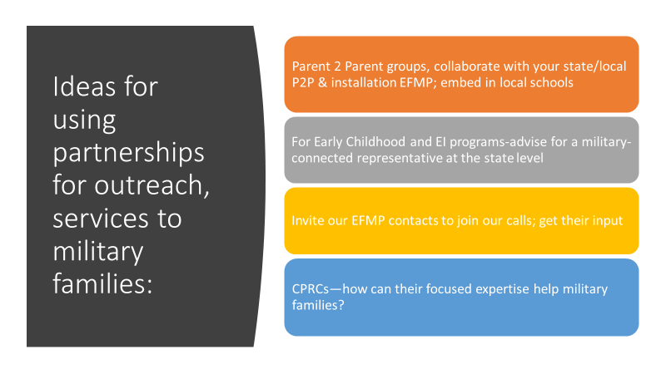

Discussion focused on two of the suggestions:
- Using parent center connections to the Parent-to-Parent (P2P) program, collaboratively with installation-based EFMPs or other military-connected personnel, might parent centers offer parent-center-facilitated organization of installation or local school-based P2P services and/or groups and P2P parent training?
  - Group response-sounds possible. Can we get more information from parent centers with current P2P relationships, and find out about mentorship and other training costs?
- Considering the geographic limitations of CPRCs, how can they reach military families if there is no installation in their catchment area?
  - Two possibilities: many active duty families live quite some distance from installations, potentially in other counties and even states (mostly for housing and education reasons). There may indeed be active duty families being served by CPRCs. If there are few or no active duty families, CPRCs will be serving Reserve, National Guard, and Veteran families who also have unique needs and could benefit from military-informed outreach and service delivery.
September 2019
YouTube video of September meeting: https://youtu.be/bDDAEeCjJyc
Burning Question to discuss in October: We can’t do the work alone. How are parent centers partnering with their state education agency, local districts, schools or others to better serve military families?
Please put on your “Creative Caps”: We’d like this discussion group to have a new name, reflecting our common interests about military family support, how we meet, and our inclusion of an parent center staff member or employee who works with, or wants to know more about, supporting military families who have a child or youth with disabilities. “Top 12 Online Group” isn’t accurate anymore, and the title above is waaaaay too long 😊 What name would help this standing discussion feel warm and welcoming to parent centers??
We welcomed:
Ginger Manley, from Parents of the Panhandle Information Network. (POPIN) in Florida. Ginger is new at POPIN, but very familiar with the military community as she is a trainer for Specialized Training of Military Parents (STOMP) and a military spouse. Ginger and Kathy Powell, also of POPIN, will represent the Florida PTIs going forward.
Loni Allen, from Parents Helping Parents (PHP) in San Jose, California. Much of her work revolves around transition and youth.
EFMP role: Fairchild Air Force has a position which welcomes families who have an Exceptional Family Member and helps with their relocation to new duty stations. The title is “Relocation Manager”. Anyone know if this position is service-wide, found in other services, unique to Fairchild, or used elsewhere?
Ombudsmen and other key volunteer positions were also discussed, see this information on branchta.org: Contact an Ombudsman!
Of Note: Jen Cole (PAVE, WA) attended the Native American Conference on Special Education in Albuquerque, NM. Native family members come from Arizona and New Mexico to attend, but also from across the country. This year a number of parent center directors were present as well. There is a strong historic and current connection with US military service among Native Americans and Pacific Islanders from US Territories.
It might be worth exploring this intersection as parent centers look for ways to enhance their outreach and services to such families.
Outreach Tools and Tips:
- When videoing a Facebook Live event, switch back and forth between presenter faces, and related images, pages, or slides to hold viewers’ attention.
- Use Twitter hashtags like #ParentTraining and #MilitaryFamilies together to catch military families’ attention
- It can take time to update your center’s website to let military families know you serve them. Social media can be a great way to direct military-connected families to your center.
Parent center tools:
AJE-DC is using a shared drive for all military-related resources so every staff member has it at their fingertips. Some current items are:
- List of contacts from an EFMP resource fair
- List of Branch Resources with parent Handouts
- EFMP Quick Reference Guide -this is the training guide used by EFMP personnel. It’s a useful resource. Please be aware that contact information and forms may change over time-this is from 2016 and is the latest available.
Checking out “Sharing” application PADLET: The Branch team has contacted Padlet to see what pricing options might work best for a) parent centers and b) this discussion group.
________________________________________________________________________________________
YouTube video of August 2019 meeting: https://youtu.be/mBo0verNsLU
August 2019
Show and Tell! Do you have photos of your time at a military-connected resource fair or training? Or, prepare to share screenshots of military family-friendly pages or images on your parent center’s website (or potential items, for those of you in process). What about a favorite handout, training that’s marketed to military families by its title or language, Facebook post, etc.? We share and get inspired….

We toured some of our parent center websites of staff on the call to share and exchange ideas from each other regarding military-specific sections or pages and discuss what we find to be useful for military families. Kudos to PIC of DE which has a brand-new dedicated page on their site, and thanks to Kathy Powell of POPIN-FND FL who suggests that this is an area we might want to keep exploring.
Websites reviewed at the meeting:
- https://fndusa.org/resources/ (POPIN, FL) -we noted the resources for rural families, parent centers in states with remote military installations could use something like this.

- https://picofdel.org/type/resources-for-military-families/ (PIC of DE)

Websites of parent centers represented at our meeting that we did not review, but it would be great to find and shout-out items or resources that military families would find especially useful!
- http://www.aje-dc.org/ (Advocates for Justice and Education, Inc., DC)
- https://wapave.org/links-for-military-families/ (PAVE, WA—we’ll be updating this based on the “Welcome to Our State” resource )
- https://www.ppmd.org/ (Parents’ Place of Maryland)
- https://pealcenter.org/ (PEAL, PA)
- https://www.peakparent.org/ (PEAK, CO)
- https://spanadvocacy.org/ (SPAN Parent Advocacy Network, NJ) and https://spanadvocacy.org/programs/military360/ (Military Family Support 360 Project, of which Peg Kinsell, on today’s call, is the Director)

- Find any parent center’s website at https://www.parentcenterhub.org/find-your-center/

The EXPO during the Military Child Education Coalition’s National Training Seminar: Branch team and Yasmeen Butler, STOMP Director shared about their booth/presentation experience and ideas for next year. Takeaways:
- The 3-way partnership of Branch, STOMP, and parent centers to bring parent center staff to co-present at installation-based STOMP trainings is a success. Program recognition among the conference attendees was high, as was enthusiasm for the STOMP trainings and parent center participation. Over 20 parent centers nationwide have joined STOMP trainers at installation workshops to offer military families TA on a host of essential topics for parents of children with disabilities, with parent centers able to enhance or initially form relationships with installation staff like EFMPs and School Liaisons.
- The joint Branch, STOMP & Parent Center booth was visited by notable dignitaries! (see pics below)
  - Julia, a Sesame Street Muppet who has autism was visiting our booth. While showing her several articles highlighting the useful, parent-and-kid-friendly resources from Sesame Street, we met:
  - Kelly Blasko, Ph.D., a psychologist with Connected Health (part of the military health care system) and the Defense Health Agency, the lead for Sesame Street for Military exclaimed “I did those!” To see the Sesame Street resources you can share with military-connected children go to: https://branchta.org/?s=sesame+street
  - EFMP Program Managers, School Liaisons and MCEC representatives.
  - MCEC’s leadership is very interested in working with parent centers across the country to offer military kids with disabilities the opportunity to create artwork that expresses their military life. MCEC has regular submissions of this work from certain areas of the country but the parent center network offers a unique chance to celebrate the military-connected kids in our states and areas. We’ll keep you posted as this idea develops.
    - To learn more about and view the resources from the 2019 Training Seminar go to: https://www.militarychild.org/nts-2019-highlights/2019-highlights

“Welcome to Our State” resource created by the online group for military families and military-connected professionals is ready for each parent center to “tweak” for their state! (see separate attachment or email Barb at bkoumjian@wapave.org)
Group-suggested uses:
- Make available to military-connected professionals at your state’s installations for them to disseminate
- Handout for resource fairs, etc.
- Turn into a web page for your center, or post the resource online for download
- Use as the basis for a training webinar
- Turn it into a video
- Other ideas? Please share!
Updates:
Kathy Powell from POPIN in north Florida: hired Ginger Manley, STOMP trainer, to work on building relationships with the Air Force installations in the area. North Florida has many installations, Navy and Air Force.
Mai Hall joined us from Parents’ Place of Maryland. She’s a military spouse, sometimes works with military families and her area of expertise at PPMD is early childhood.
Anya Frederickson and Barbie Saunders from the PEAL centers in PA joined us—PEAL has two sites, Philadelphia (Barbie) and Pittsburgh (Anya).
Yasmeen Butler, STOMP Director, reports that they are finishing off this year’s contracts with the Army, Navy and Air Force. Upcoming trainings
LaJoy Johnson-Law, AJE-DC, attended her first EFMP Resource Fair at Joint Base Anacostia-Bolling, where she made many contacts. She created a “Quick Guide” based on the resources she knows and learned about—will share later with the group.
Shirley Swope at PEAK in CO will be at the STOMP training coming up at Peterson Air Force Base, she looks forward always to working with the STOMP trainers and enjoys seeing the EFMP there.
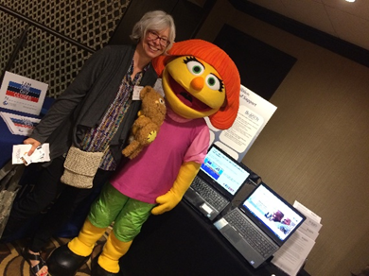
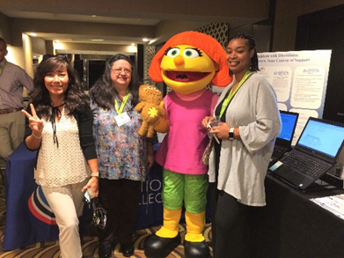
Figure 1: Dr. Kelly Blasko, Defense Health Agency, and Julia, Muppet from Sesame Street. Julia is the lead Muppet in Sesame Street's autism initiative, developed for military families and available to everyone.
Figure 2: Jen Cole, PTI/PAVE, Barb Koumjian, Branch, Julia, Sesame Street, Yasmeen Butler, STOMP-at MCEC Expo '19. STOMP/Branch presentation in background.

________________________________________________________________________________________
YouTube video of July 2019 meeting: https://youtu.be/Ucc8WuKrIbk
The “Welcome to Our State” resource created by this group for military families and military-connected professionals is ready for each parent center to “tweak” for their state.
The Branch will be launching this resource across the parent center network in September.
Group-suggested uses:
- Make available to military-connected professionals at your state’s installations for them to disseminate
- Handout for resource fairs, etc.
- Turn into a web page for your center, or post the resource online for download
- Use as the basis for a training webinar
- Turn it into a video
Or?
We welcomed several members of the Region A Military Family Support Community of Practice.
- LaJoy Johnson-Law, Advocates for Justice & Education DC (AJE-DC)
- Barbie Saunders, Americorps/PEAL Parent Center, PA (PEAL)
- Tina Andrews of Parent Information Center of Delaware. (PIC)
They shared their parent center’s new initiatives for outreach and services to military families:
AJE-DC is attending an upcoming resource fair at the local Joint Base! They are asking their state education agency for data on military children and families and collaborating with Heather Luke at Parents Place of Maryland on outreach ideas. They have updated their intake forms to ID military families.
PEAL is poised to see how they can have effective military family outreach in PA. They are checking out veterans’ job fairs and similar events to identify opportunities to reach out.
PIC has developed a relationship with the School Liaison at Dover AFB, and they are setting up workshops and events for the upcoming year, and PIC will be on the agenda at Dover’s Parent Council Meeting. They are updating their website to be military-friendly, they’ve added a military identifier to their Salesforce database, and they have also been in contact with her state’s Joining Forces Committee—a project which brings together Reservists, National Guards, veterans, etc., identifies local needs and creates outreach.
Updates:
Roz from PAVE, WA, mentioned her close work with Fairchild AFB. Other PAVE staff have relationships with installations in their area of responsibility.
FCSC in SC has ongoing work at Ft. Jackson, they continue to work to make connections at other installations in their state
PEAK in CO regularly works with military families from Ft. Carson, Peterson and Schriever AFBs, and the Air Force Academy, offers trainings on the installations and will be participating in the STOMP 2-day workshop in August.
ECAC in NC has an ongoing relationship with Ft. Bragg. ECAC staff plan to use the new resource this group created to re-ignite interest in working with ECAC on the part of the EFMPs, SLOs, etc. at the other major installations in the state.
Shannon from Partners Resource Network in TX is near a Joint Reserve Base where the relationships she has built with their EFMP results in regular referrals of families to PRN; other PRN staff work as well with installations in their areas of TX.

